|  |  |  |  |  |  |
| --- | --- | --- | --- | --- | --- |
| Date | 12-Dec-22 | | | Tester Name | Janette Paus |
| Environment | Penfax - Test 2 | | | Login used | <If different from the Tester> |
| Operating System | Windows | Version: 21H2 | Update Number: | | |
| Software Used | Select Software | Version: 107.0.1418.56 | Update Number: | | |
| Select Software | Version: | Update Number: | | |
| Application Release version | R22.4.1 | | | | |
| Test Case Title | E13.16 | | | | |
| Test Type | Regression | | | | |
| Test Scenario | Remove a Beneficiary - PENWEB | | | | |
| Expected Results | The beneficiary is removed through PENWEB and reflected in PENFAX | | | | |
| Pass/Fail | Pass | | | JIRA# |  |

Search for a member to remove a beneficiary through PENWEB

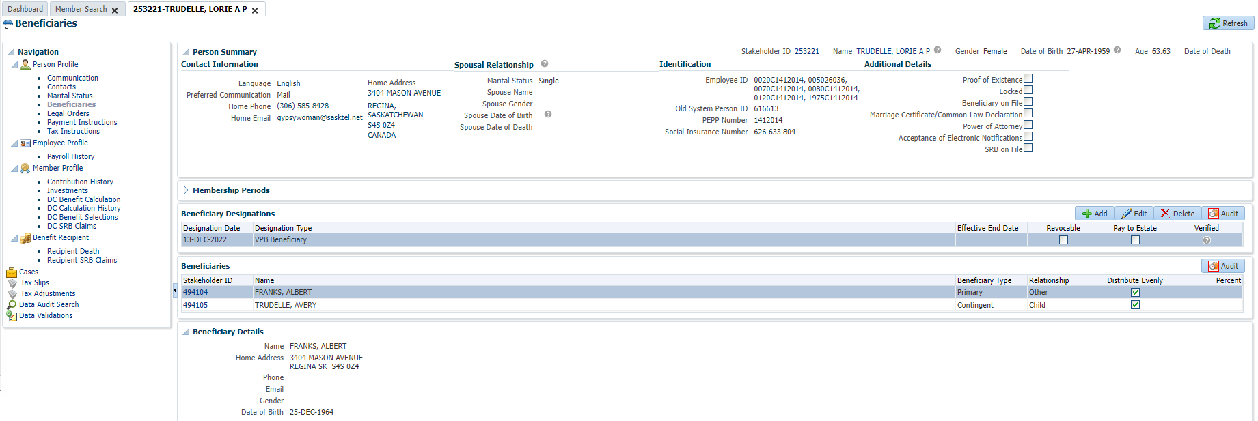

Open that member in Planet member PEPP

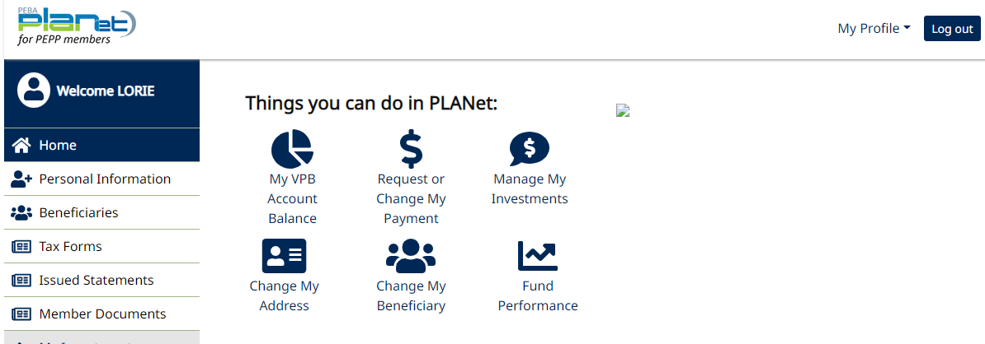

Under Beneficiary tab, add/change Beneficiary

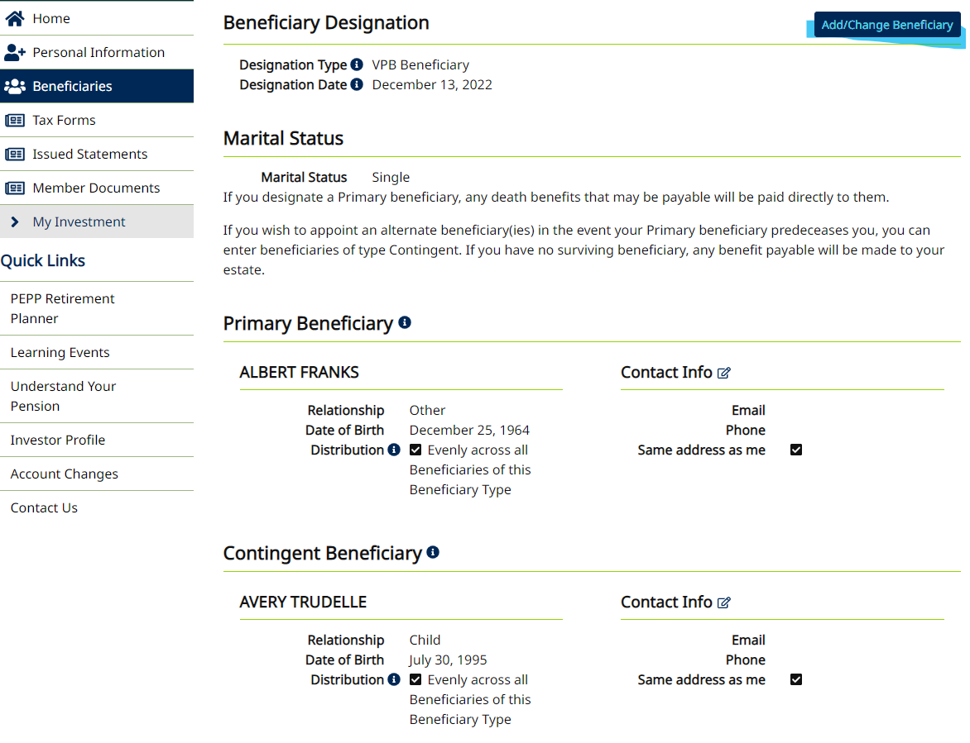

Select Remove Beneficiary for the beneficiary to be removed

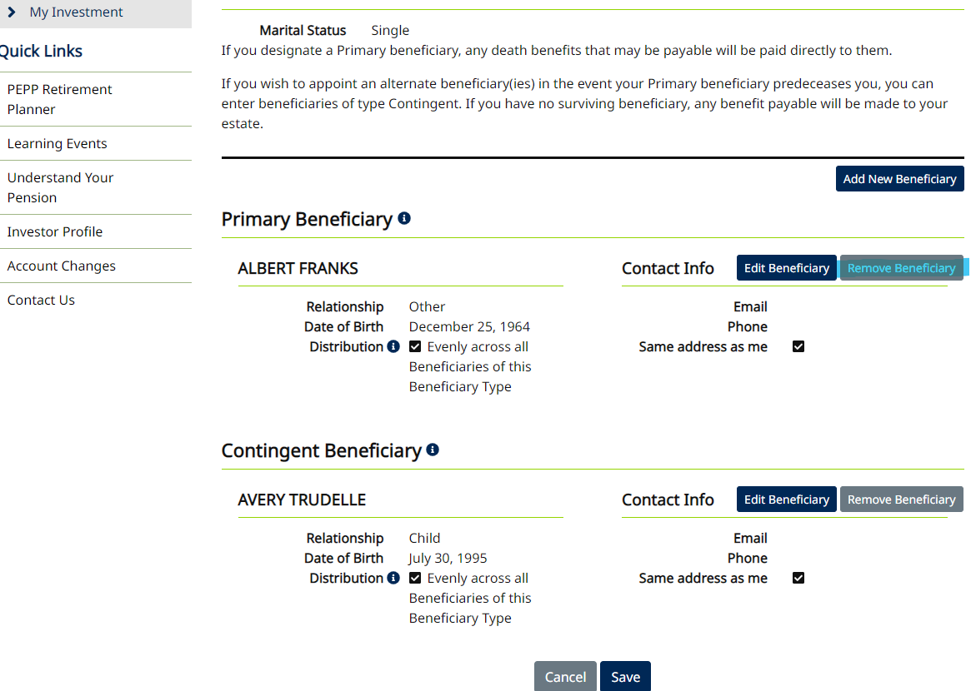

Edit Contingent Beneficiary – change to Primary

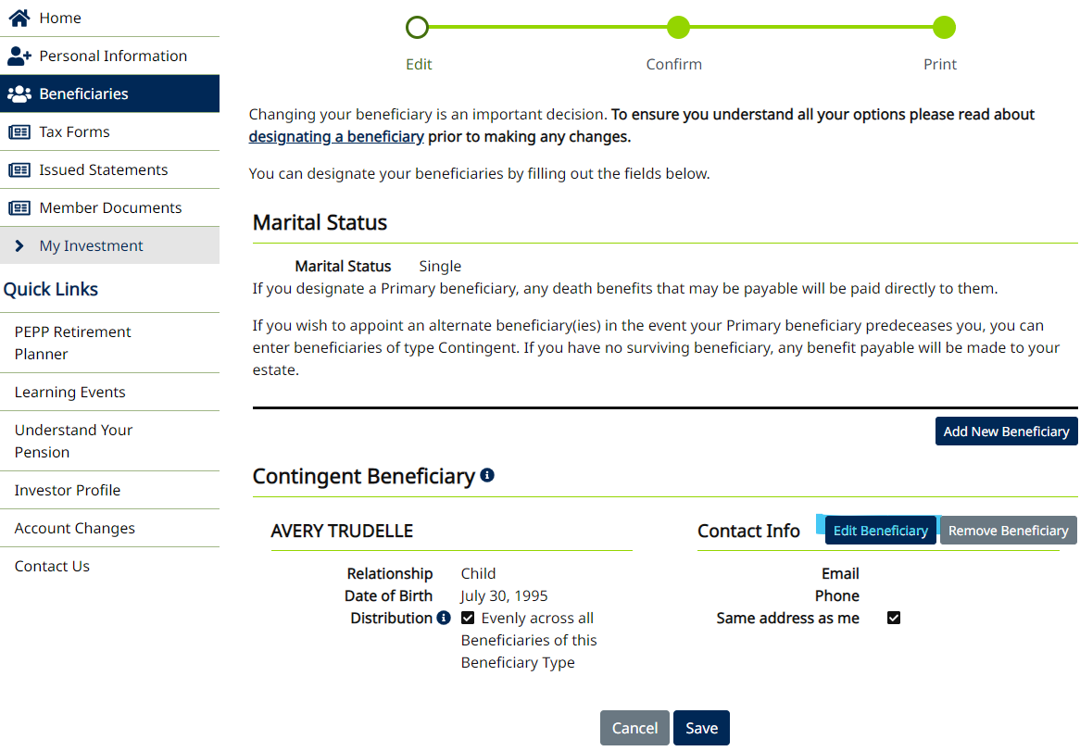

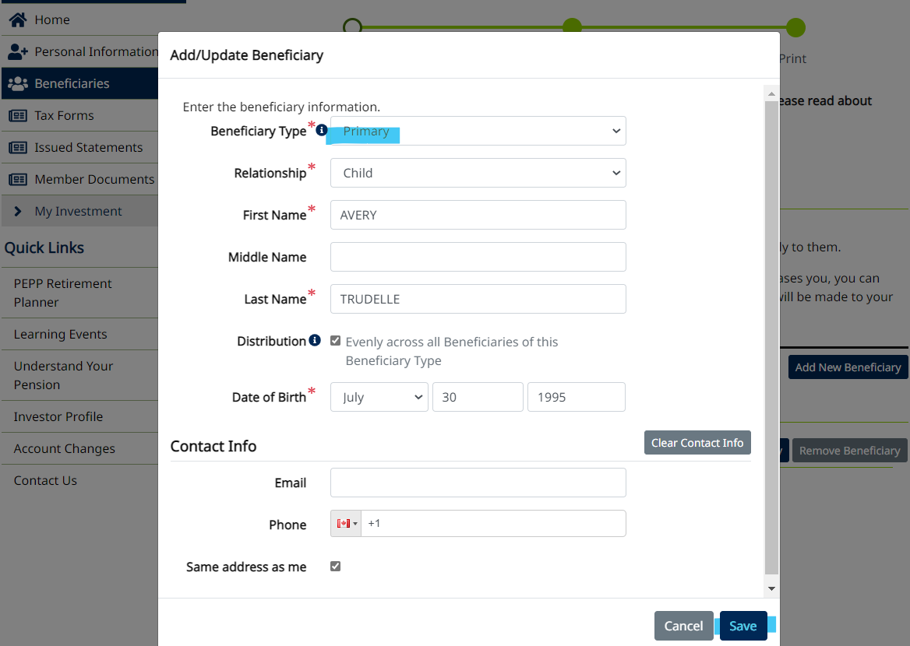

Save

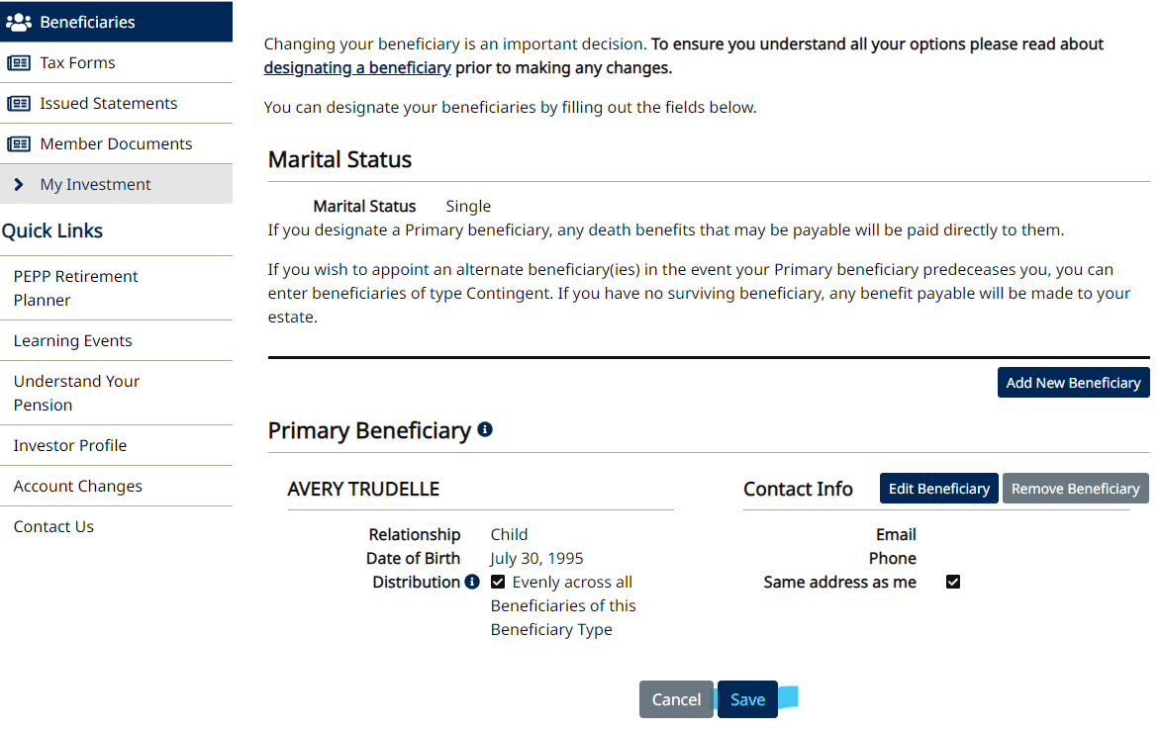

Confirm removal

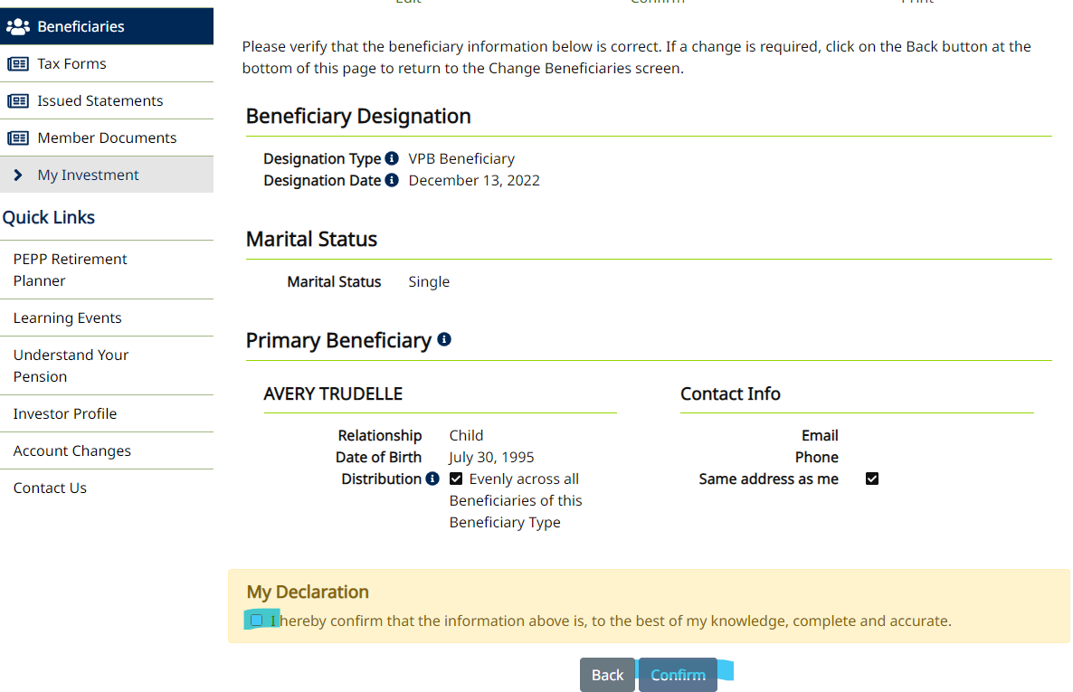

Print if needed

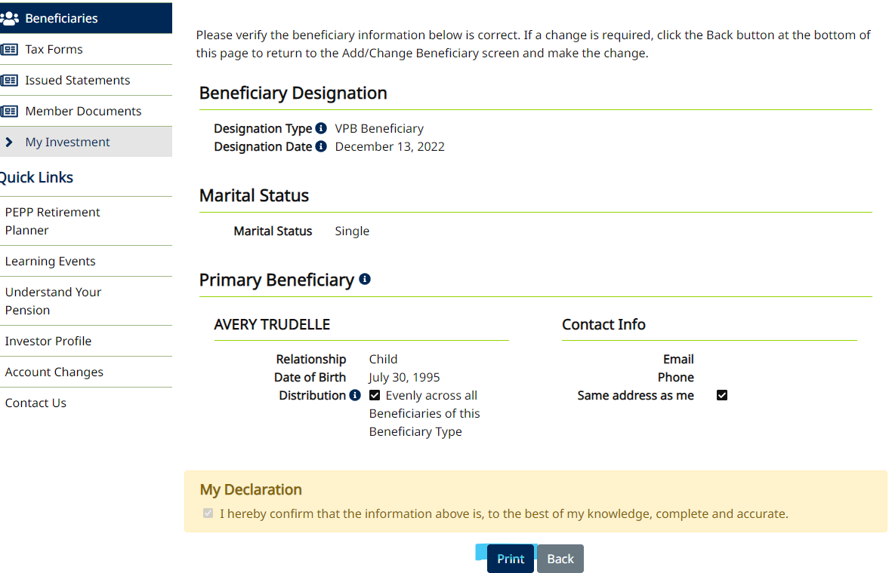

Refresh and beneficiary is removed

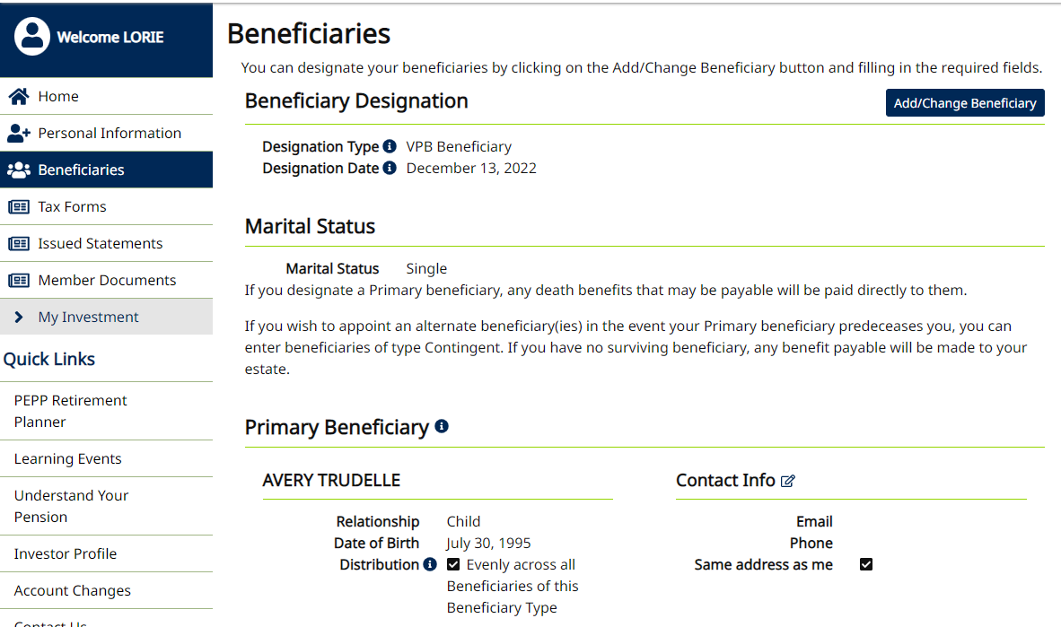

Confirm on PENFAX

